Accessibility as Dramaturgy

Kaya Wanju.

We acknowledge the land on which The Blue Room Theatre sits, Whadjuk Noongar Boodja, and pay our respects to elders of this land, past and present. We acknowledge that stories have been shared on this land over thousands and thousands of years, and that this building marks a footprint on what is and always will be Aboriginal land.

Thank you for joining us for this stimulating conversation on ‘Accessibility as Dramaturgy’ that concludes Kolyang Artist Lab for 2022.

How does accessibility influence creative practice and performances? We often think of it in terms of how audiences engage with work once it’s finished, but what if it was embedded in the process of making and telling stories? Is ‘accessibility as dramaturgy’ just another buzz phrase or something that should be applied to our creative process and work?

This event is brought to you by Performing Lines WA and
The Blue Room Theatre.

It is hosted by Jeremy Smith (Performing Lines WA) and Caroline Bowditch (Arts Access Victoria) with special guests Bruno Booth and Georgi Ivers.

An Introduction and Reflections by Daisy Sanders

My name is Daisy Sanders. I work in devised performance including dance, theatre, experimental practice and sensory theatre for children with diverse needs and abilities. I do not identify as having a disability but I experienced chronic illness for five years and have ongoing access needs.
I think about dramaturgy in 2 key ways.

- In performance-making dramaturgy is (perhaps) an overarching analysis of meaning, relationships intentions and connections. The dramaturge is not the director attending to detail of what is happening, instead they are looking at the why, the how, the big picture - contextualising the work, provoking reflection on its deep value and impact.
- For me, dramaturgy extends to ecologies of practice: how we meet as artists, the dynamics and relationships in the room, the arrangement of process, people, time and space that enables us to work. I think of the dramaturg as the person asking questions, noticing contexts, nudging conversations and shifting the conditions. I am the dramaturg of my every day activities - life dramaturgy is a game and practice I thoroughly enjoy.

I look at the word ‘accessibility’ and think about: ability to access.

Reflection 1 - ACCESS TOOLS AS CREATIVE IMPETUS
In 2021 I made an online work through Arts Centre Melbourne called Room To Rest. It was a curious experience in which a major venue challenged me to maximise the mechanisms for access that could be included (ie. Auslan interpreter, subtitles, audio description etc). Rather than making my work then overlaying these, the conversation throughout the creative process was: how can numerous approaches to communication be woven into this video dance work? I spoke, I danced, I wrote things big and visible, I considered the Auslan interpreter my duet dance partner. The soundscape was a rich, full experience in itself. It was a multi sensory work with multiple modes of communication. In this way the access became the dramaturgy of the work.

Reflection 2 - PRODUCING AND PERFORMING ACCESSIBLE WORK
Ability to access art experiences is also about time, personal experience, and deep engagement. I love the term ‘universal access’ in theory, but access needs range greatly from person to person. It takes patience, communication, and hard work to genuinely know the needs of artists and/or audience then tailor on a case-by case basis both how we work and the art we make.

And so, I propose that accessibility can't be comprehensively achieved if we subscribe to functioning at a high paced, outcome driven rate of work. Time has to be ample, elastic and flexible. Making work over years, feeling when the work is ready rather than pushing it to BE ready, choosing a rate of life admin that doesn’t rush or stress ourselves or others - these are all acts of access in producing art.

Perhaps access is about quality over quantity, ensuring deep listening and offering to each other. Certainly, this is the case in my work as a Sensorium Theatre artist. We spend much time refining presence - becoming embodied, heart-centred, generous, and sensing when engaging our audiences of children with diverse needs and abilities. Sensorium shows have magnificent design, music, story and choreography, but to me the most powerful aspect is how we attend to each and every child. This presence creates the spirit of the work - it is the fundamental dramaturgy, a unique tone and feel that enables accessibility.

Reflection 3 - DEVISING BY HONOURING ACCESS NEEDS
My multidisciplinary dance and installation work A Resting Mess started in 2016 at the depth of my illness. I lay in a gallery and was too tired to tidy my possessions. I used a beanbag to relieve fatigue and to slide around writing on the gallery walls (capturing instant poetry and reflections there eased my brain fog). I danced whenever I could and rested whenever I needed to. All of these basic actions, directly responsive to my access need, are the foundations of the work. They have become the set and design style, the dance/choreographic method, the audience seating and the message of the work. A Resting Mess proposes rest as an essential, radical response for facing the chaos, pace and complexity of our world. (For those interested the next development is this September with The Last Great Hunt.)

I let every single thing that my health conditions needed in that first development to be there. I honoured and explored my body’s limitations, I noticed the details and allowed those things to become the character and creative features of my work. Maybe the dramaturgy of access is being all that we are, with all that we need, and allowing that to give birth to creative dreaming and devising. (Now that the work has grown, and I have become more healthy, I still return to the fundamental aspect of listening to the changing energy in my body and letting that guide both creation and performance of the work. If I abandoned this deeply embodied focus on access and care, the fundamental dramaturgy of the work would disappear.)

Meet the Panellists

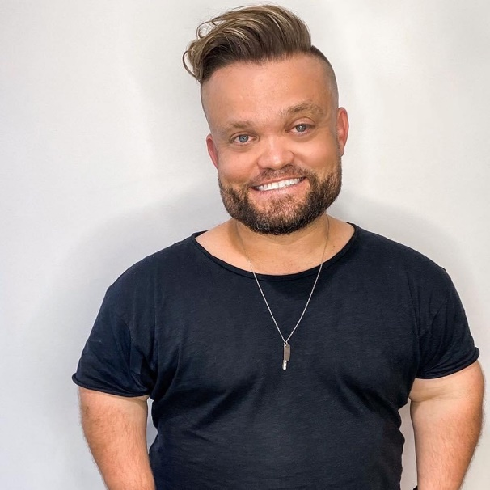
Jeremy Smith is the Senior Producer at Performing Lines WA where he works closely with independent artists working across performance disciplines.
In April 2020, he returned to Boorloo/Perth after four years at the Australia Council for the Arts as Director – Community Arts and Experimental Arts.

He worked closely with artists, organisations and communities across the country promoting artistic bravery, self-determination and brokering opportunities. In addition to his extensive portfolio, Jeremy championed Regional and Remote Australia under the Australia Council’s Cultural Engagement Framework and helped develop and deliver key arts and disability initiatives.

As the General Manager of the Perth Institute of Contemporary Arts (PICA), Jeremy loved working within a contemporary arts organisation supporting the development, presentation and commissioning of work by leading interdisciplinary artists. He is a board member of both the Chamber of Arts and Culture WA and pvi collective.

He has held a range of senior positions in the corporate, not for profit and government sectors in Western Australia, including with DADAA, the AWESOME Festival and ArtsWA / Department of Culture and the Arts. He is a graduate of WAAPA, and worked as a freelance lighting designer, production manager and creative producer in the early stages of his career.

As a disabled man, Jeremy is a fierce advocate of celebrating difference and transforming attitudes which ‘other’ people in our community. He also promotes actions to ensure these values are central to our arts, cultural and creative industries.

Jeremy loves his ‘anti-bio’ – far more impressive than this dull, corporate overview – and he strongly encourages you to take time to read it here.

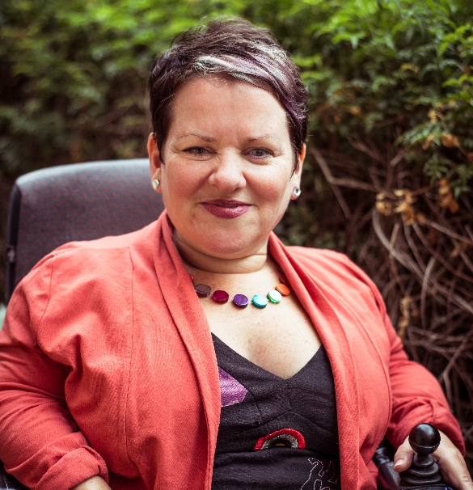
Caroline Bowditch is the Chief Executive Officer/Artistic Director of Arts Access Victoria and the Creative Lead of the Alter State Festival at Arts Centre Melbourne. Caroline enjoyed an acclaimed career in the UK for over 16 years as a performance maker and industry leader. Caroline was Scottish Dance Theatre’s Dance Agent for Change (2008-2012). She was an Director of Dance with Paragon Music (Glasgow), Dance4 (Nottingham) and Imaginate (Scotland), and was Visiting Professor at Coventry University. She has been a regular consultant on accessibility and inclusive practice to Skånes Dansteater, Sweden, and the British Council.

Caroline’s performance works include Leaving Limbo Landing (2012), an Unlimited festival commission for the Cultural Olympiad, Falling in Love with Frida (2014), which was awarded a prestigious Herald Angel award, and children’s works, The Adventures of Snigel and Snigel and Friends (2016) which was nominated for a Total Theatre Award, Edinburgh Festival (2017).
Caroline returned to Australia to lead Arts Access Victoria.

During her tenure, Caroline has developed strong partnerships with Arts Centre Melbourne, Regional Arts Victoria, MAV (formerly Multicultural Arts Victoria), Melbourne Fringe Festival, Music Victoria and many more. Caroline’s strong advocacy has resulted in significant reform of funding programs for Deaf and Disabled artists. Caroline has overseen the development of a new Strategic Plan at Arts Access Victoria and led the organisation through a successful transition to hybrid delivery throughout the COVID-19 pandemic. Arts Access Victoria’s vision is cultural equity for all Deaf and Disabled people. Caroline’s leadership is grounded in delivering on this vision in the years ahead.

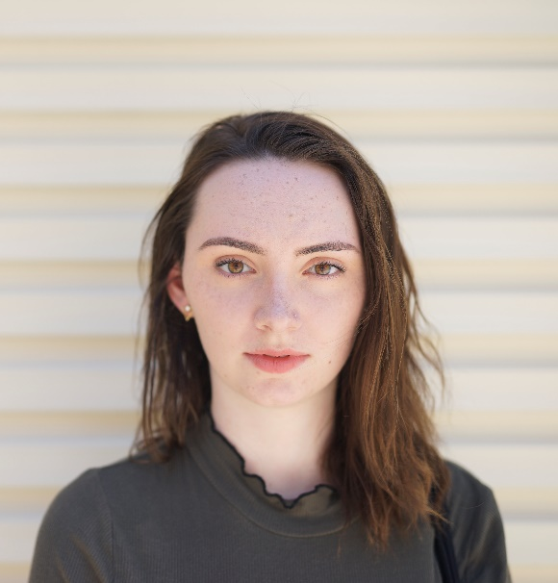
Georgi Ivers is a performer, theatre-maker and multimedia artist in Boorloo. She is currently developing You're So Brave, an autobiographical solo show about living with chronic illness, with director Joe Paradise Lui at the Blue Room Theatre this October. Her most recent multimedia/theatre projects were Beginning At The End (of Capitalism) (The Blue Room), for which she is nominated for Outstanding Stage Design for her live cinematography (PAWA Awards 2022); The Dirty Mother (The Blue Room, State of Play), which was rebirthed online with Georgi’s digital direction and nominated for Best Theatre at Melbourne Fringe 2020); and collaborating with Daisy Sanders to digitise her movement work Room To Rest for Alter State Digital (Arts Centre Melbourne).

Georgi has worked extensively with the WA Youth Theatre Company on Perth Festival and Fringe productions as a performer, assistant director and associate artist (BESIDE, Body Rights). She has a BA Screen Production (Curtin University/City University of Hong Kong) and has been pole dancing since 2019.

First diagnosed with Ankylosing Spondylitis (autoimmune arthritis) at 17, Fibromyalgia (widespread pain) at 18 and Crohns Disease (inflammatory bowel disease) at 26, Georgi's first specialist found her very interesting. Georgi's relationship with illness has been closely tied to her immediate family, all of whom received at least one chronic illness diagnosis within a five year period. Her health is dynamic and moves in cycles between being well-medicated and able, to unpredictable transition periods between treatments, and times where she experiences extreme pain, can't walk, may or may not shit herself, and/or sleeps a lot. She still regularly bleeds out of her bumhole.

Georgi first began reading about Disability Rights when she was at university, where she learned how statistically unlikely she was to graduate. Fortunately, Curtin offered fabulous support programs and flexible study, and she has had good access to (fairly) affordable healthcare. When offered the opportunity to run for Students with Disabilities Officer at the Curtin Student Guild, Georgi declined as she wasn't sure whether her experience "counted". She has discovered that being invisibly ill comes with its own advantages and difficulties in an ableist system that expects constant and consistent production, and sees deviation as unreliable and unprofessional. Making You're So Brave, a solo show about living with chronic illness, was a huge and scary decision by Georgi to disclose her reality to the broader arts community.

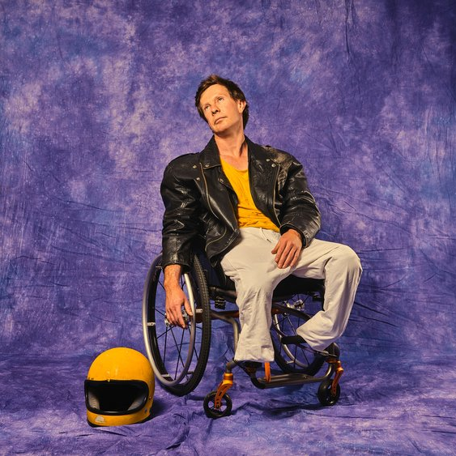
Bruno Booth has used a wheelchair for most of his life, interrupted by a short and unsuccessful career as an amateur stilt walker when he used prosthetic legs as a child. In his memory these leather and metal devices would not have been out of place on the set of some dystopian, apocalyptic epic – not in a cool and attractive Fury Road sort of way, more like the zombies in the original Walking Dead. The experience of wearing restrictive equipment left him with a dislike of tight fitting clothing, a love of speed and a need to reach over his head in supermarkets – as a child he made the decision to use a wheelchair as his primary mode of transport – and he’s never looked back (probably because he’s too busy looking out for sand pits on dark footpaths).

Having a disability has been a constant background hum throughout Bruno’s life. Kind of like a social tinnitus – you know it’s there but you try not to talk about it. It was only when he started to call himself an artist, without cringing too much, that he began to engage critically with what it meant to be categorised as disabled.

To read all the dry details about Bruno’s career click here.

